Sockets Lab

Modify MessageClient so that it does something meaningful.

Design an Application Protocol

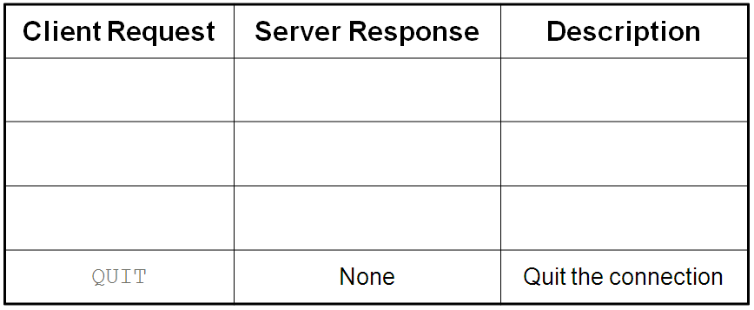

You must have at least 3 client request commands besides QUIT. You may add as many as you need.

Modify MessageClient so that it repeats until the user puts in the menu item to QUIT.

Modify MessageServer so that it continues to read from the inputStream and returns the appropriate responses to the menu in the MessageClient based on your Application Protocol, until it receives the QUIT request from the client.

Upload your modified MessageClient.java, MessageServer.java and your Application Protocol (in a .doc or .docx file).